SRIVARU (SVMH) Begins PRANA 2.0 Vehicle Deliveries and Revenue Generation

GRAND CAYMAN, KY1-1006, CAYMAN ISLANDS, October 14, 2024 — SRIVARU Holding Limited (Nasdaq: SVMH, SVMHW) (“SRIVARU” or the “Company”), a manufacturer of premium electric motorcycles, today announced the commencement of customer deliveries for its PRANA 2.0 models, including the PRANA Grand and PRANA Elite. This milestone also signifies the beginning of the Company’s revenue generation phase.

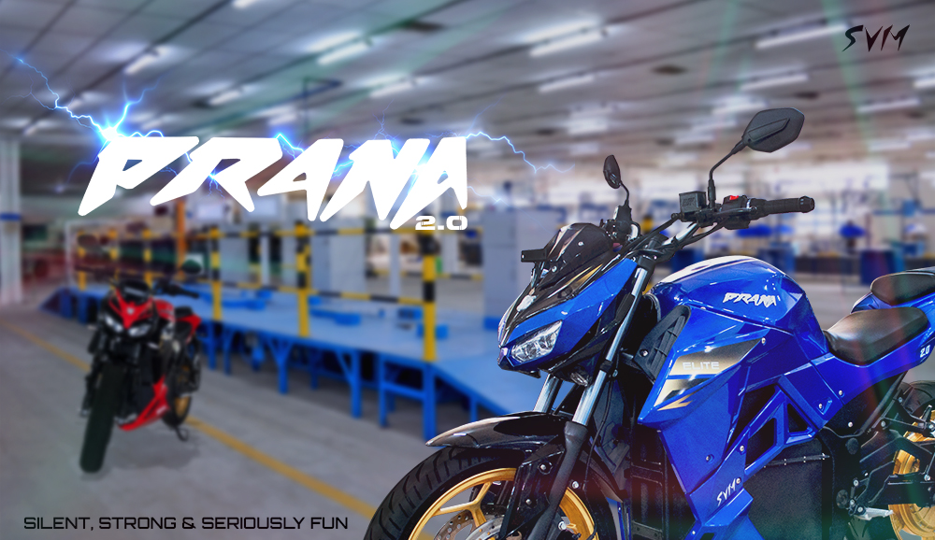

The deliveries follow SRIVARU’s receipt of the critical CMVR certification from the Indian Road Transport Authority and subsequent approval from the State Transport Authority. This certification confirms that SRIVARU meets India's rigorous safety, performance, and environmental standards, positioning the company to fully capitalize on India’s rapidly growing electric vehicle (EV) market—one of the largest two-wheeler markets in the world.

Vehicle delivery represents a significant milestone for the Company, marking the start of revenue generation from product sales. SRIVARU has developed a strong supply chain and advanced manufacturing facility, featuring an automated test line, which allows the Company to certify, sell, and deliver products efficiently to its customers. With a streamlined supply chain in place, SRIVARU has established an effective costing model that enables the Company to realize gross profit on each sale, driving positive revenue growth.

The PRANA 2.0 series, featuring the Grand and Elite models, is designed to offer a superior riding experience with state-of-the-art technology, impressive range, and high-performance capabilities. Built for urban commuters and eco-conscious riders, PRANA 2.0 motorcycles boast a sleek design, advanced safety features, and powerful electric drivetrains, setting a new benchmark in the premium electric motorcycle segment. With an impressive range of 250 kilometers per charge and the capability to accelerate from 0 to 60 km/h in under 4 seconds, the PRANA 2.0 series are both the fastest and most efficient electric motorcycles in their class available in India today. PRANA 2.0 vehicles are equipped with iOT enabled smart clusters having LTE and Bluetooth connectivity. PRANA 2.0 motorcycles also have advanced Controller Area Communications (CAN) between the core components of the motorcycle, such as the primary controller, charger, battery and cluster. The advanced CAN implementation enables the integration of artificial intelligence to monitor specific vehicle parameters and make predictions, ultimately enhancing the user experience. This includes providing more accurate information, such as the remaining driving range, by factoring in the vehicle’s current consumption, remaining energy, and regenerative currents.

Mohanraj Ramasamy, CEO of SRIVARU, stated, "We are thrilled to begin product deliveries of the PRANA 2.0 models and officially enter into a phase of revenue generation. The PRANA 2.0 series reflects our commitment to innovation, sustainability, and superior riding experience. These models are built for riders who demand both performance and cutting-edge technology, while contributing to a greener planet. We are excited about the growth opportunities ahead as we continue to expand our footprint in the electric two-wheeler segment."

"India's economic transformation, fueled by rising per capita income and substantial policy initiatives, is paving the way for premium, user-focused products. With our cutting-edge electric motorcycles, SRIVARU is poised to play a key role in shaping a cleaner, greener future for India, while meeting the growing aspirations of our people," concluded Mr. Ramasamy.

For more information about the PRANA 2.0 and SRIVARU, please visit https://www.srivarumotors.com/prana-electric-bike or www.svmh.ai.

About SRIVARU

SRIVARU Holding Limited, a Cayman Islands exempted company, is the parent company of SRIVARU Motor Private Ltd., a commercial-stage provider dedicated to designing and manufacturing premium electric motorcycles in India. SRIVARU was founded on the realization that while the rider-motorcycle relationship is deep and complex, it is in desperate need of innovation for the next generation of riders. SRIVARU provides affordable premium E2W vehicles that provide an exceptional riding experience with redundant 3-channel automated braking, a low center of gravity to improve stability, enhanced safety features, and easy charging compatible with home charging outlets. The Company has a broad array of intellectual property, including a patent-pending chassis and drive acceleration system. In addition, SRIVARU offers customers a superior total cost of ownership compared to traditional internal combustion engine motorcycles and E2W vehicle competitors. SRIVARU additionally oversees a manufacturing subsidiary set to play a crucial role in achieving the company’s vision for sustainable and innovative mobility. Additional information about the company is available at: http://www.srivarumotors.com/. With a focus on innovation, sustainability, and performance, SRIVARU aims to redefine the future of mobility.

Forward Looking Statements

This communication may contain a number of “forward-looking statements” as defined in the Private Securities Litigation Reform Act of 1995. Forward-looking statements include information concerning SRIVARU’s possible or assumed future results of operations, business strategies, debt levels, competitive position, industry environment, potential growth opportunities and the effects of regulation, respectively. These forward-looking statements are based on SRIVARU’s management’s current expectations, estimates, projections and beliefs, as well as a number of assumptions concerning future events. When used in this communication, the words “estimates,” “projected,” “expects,” “anticipates,” “forecasts,” “plans,” “intends,” “believes,” “seeks,” “may,” “will,” “should,” “future,” “propose” and variations of these words or similar expressions (or the negative versions of such words or expressions) are intended to identify forward-looking statements.

These forward-looking statements are not guarantees of future performance, conditions or results, and involve a number of known and unknown risks, uncertainties, assumptions and other important factors, many of which are outside SRIVARU’s management’s control, that could cause actual results to differ materially from the results discussed in the forward-looking statements. These risks, uncertainties, assumptions and other important factors include, but are not limited to: (a) the outcome of any legal proceedings that may be instituted against SRIVARU or others; (b) the inability to obtain financing to complete the Company’s planned expansion; (c) the inability to successfully appeal the Nasdaq’s delisting determinations; (d) the ability of SRIVARU to grow and manage growth profitably, maintain relationships with customers and suppliers and retain its management and key employees; (e) costs related to ongoing operations; (f) the possibility that SRIVARU may be adversely affected by other economic, business, and/or competitive factors; (g) SRIVARU’s ability to execute its business plans and strategies, (h) SRIVARU’s estimates of expenses and profitability, and (i) other risks and uncertainties indicated from time to time in SRIVARU’s public filings with the SEC, including those under “Risk Factors” therein.

Forward-looking statements speak only as of the date they are made. Readers are cautioned not to put undue reliance on forward-looking statements, and SRIVARU assumes no obligation and, except as required by law, do not intend to update or revise these forward-looking statements, whether as a result of new information, future events, or otherwise. SRIVARU gives no assurance that it will achieve its expectations.

Company Details:

SRIVARU Holding Limited
2nd Floor, Regatta Office Park, West Bay Road
P.O. Box 10655
Grand Cayman, KY1-1006
Cayman Islands

Investor & Media Contact:

Investor Relations
SRIVARU Holding Limited
Email: ir@srivarumotors.com
Phone: +1 (888) 227-8066

